Communication for Health Care Professionals 1
NCSI1182A
Module 2 Effective Communication
Krystal Pitre/ Betty Lydon June 2023
Think About It!

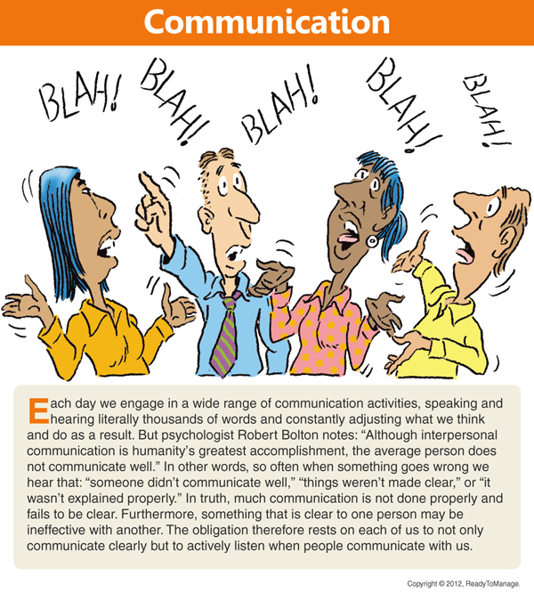

References:

In this module:

Goal: To discuss the bridges to effective communication.
Competencies:
Discuss bridges that support effective communication
  - respect
  - caring
  - mutuality
  - empowerment
  - trust
  - empathy
Readings: Arnold and Boggs’s Interpersonal Relationships; Professional Skills For Canadian Nurses.
The greatest problem with communication is the illusion that
communication has even taken place.
George Bernard Shaw

Bridges The Support Effective Communication

“Communication between health care providers and the people being cared for impacts the way care is delivered; it is as important as the care itself. Outcomes of effective interpersonal communication in health care relate to higher person satisfaction, quality care, and productive health changes. People are more likely to understand their health conditions through meaningful communication and to alert providers when something feels wrong” (Arnold and Boggs, pg. 10)
When communicating with someone would you rather speak to someone who has knowledge and seems interested or someone who makes it feel like you are speaking to a brick wall?
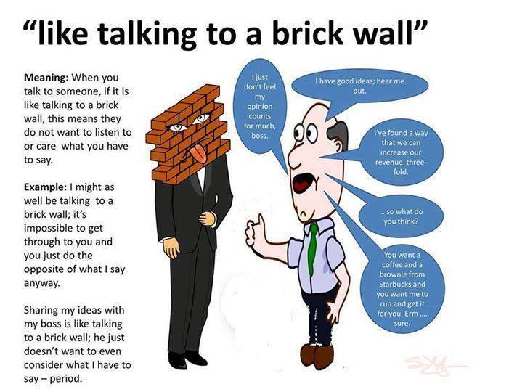
“Two-way communication provides the opportunity to share information, to be heard, and to be validated. Having the opportunity to provide input empowers persons and families to take a stronger position in contributing to their health care” (Arnold and Boggs, pg. 10).
“Communication is the key to safe health care. When health care workers communicate effectively, fewer errors occur, and people are more satisfied. The majority of errors in health care are linked to a lack of proper communication. This lack of communication can be between nurses; among interprofessional teams, including physicians; with physiotherapists, occupational therapists, dietitians, social workers, and pharmacists; or with any member of the health care team. Since patient safety is the first priority in nursing care, effective communication should be incorporated in all of the components of planning so that nurses can provide the highest quality of care” (Arnold and Boggs, pg. 18).
The following concepts describe methods to help you improve your communication skills in bridging and avoiding barriers (Fig. 12.1).
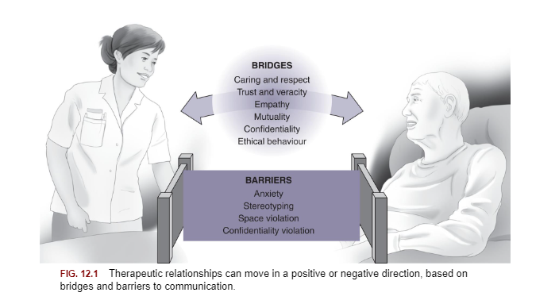
(Arnold and Boggs, pg. 227).

Respect
Remember the “Golden Rule” our families and teachers have taught us “Treat others how you wish to be treated”. Without respect you cannot develop a positive professional relationship with an individual.

Reference:
Your goal should be to “maximize the person’s health status, you need to have respect for their knowledge, values, opinions, and life experiences. Asking them what they prefer to be called and always addressing them as such is the correct initial step. Using names such as “Honey,” “Dear,” or “Sweetie,” or using the word “we” in the context of, “How are we feeling today?” should be avoided. It is important to remember that people who are hospitalized or have health care needs are defined by who they are, not by their disease or health issues. We need to avoid these terms because they take from a person’s sense of control when it comes to their relationships with health care providers” (Arnold and Boggs, pg. 227).
Lack of Respect
“People report feeling devalued when they perceive that staff were avoiding talking with them or were unfriendly; they felt comforted when social conversations were included in communications” (Arnold and Boggs, pg. 227).

Caring
“Caring is an intentional human action characterized by commitment and a level of knowledge and skill to allow you to support basic integrity. You offer care to the person and family by means of a therapeutic relationship… It is important to develop and sustain a helping, trusting and caring relationship with people as well as their families. This is to create a caring healing environment to care for the persons mind, body and spirit” (Arnold and Boggs, pg. 227). .
Canadian nursing theorist Sister Simone Roach (1992) describes the 6 C’s of what nurses do when they are caring:

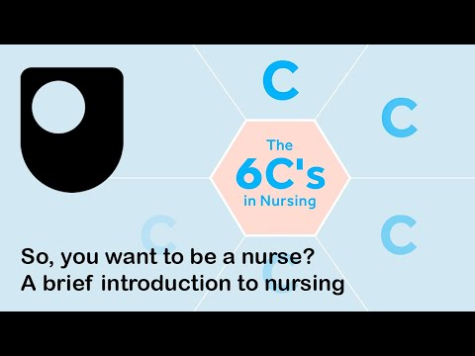

“Providing a caring relationship that facilitates health and well-being is an expectation in all provincial and territorial nursing practice standards. For example, in the Standards of Practice for Licensed Practical Nurses (LPN) in Canada, it states, “LPNs are self-regulating and accountable for providing safe, competent, compassionate and ethical care within the legal and ethical framework of nursing regulation” (Canadian Council for Practical Nurse Regulators, 2013, p. 4).
“The behaviour of “caring” is not only and emotional feeling but also involves the following:
- Knowing- Nurses knowledge of the patients needs.
- Being-Verbal and nonverbal interactions that occur during the therapeutic relationship.
- Doing-Nursing interventions that demonstrate caring while striving to achieve the best health outcomes” (Swanson, 1991)

“C.A.R.E” approach.
Healthcare professionals should try to follow the “C.A.R.E” approach to communication.
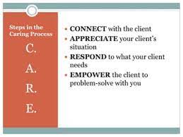
Reference:

Mutuality

Mutuality - The dictionary meaning of this word is “the sharing of a feeling, action, or relationship between two or more parties”
“Mutuality is when you recognize the benefit of exchanging things with others, and value and support the well-being of people (Berezin &amp; Lamont, 2016). It means that the nurse and person agree on the person’s health issues and the means for resolving them. Both parties are committed to enhancing the person’s well-being. This is characterized by mutual respect for the autonomy and value system of the other. In developing mutuality, you maximize the person’s involvement in all phases of the nursing process. Mutuality is collaboration in problem-solving and guides communication at the initial encounter” (Arnold and Boggs, pg. 231). Mutuality is team nursing (this includes the client) working relationships in healthcare to obtain a common goal.

“As nurses, we respect interpersonal differences. We involve the person in the decision-making process as an equal partner. We accept their decisions even if we do not agree with them. Effective use of self-awareness and values clarification assists you to support people in decision making. Those who clearly identify their own personal values are better able to solve problems effectively. Decisions then have meaning to the person. There is a greater probability that they will work to achieve success. When a mutual relationship is terminated, both parties experience a sense of shared accomplishment and satisfaction” (Arnold and Boggs, pg. 232).

Empowerment

“Empowerment is defined as assisting people to take charge of their lives… Our nursing goal is to use communication skills that build bridges to form partnerships that mold the person and family’s empowerment. We use the interpersonal process to provide information, tools, and resources that help people build knowledge and skills to reach their health goals.
Empowerment is an important aim in every nurse–person relationship. Empowered people feel valued and are more likely to adopt successful coping and self-management strategies. Studies demonstrate that the more involved people are in their own care, the better the health outcomes” (Arnold and Boggs, pg. 229).
This video focuses on chronic conditions but is true for all conditions.
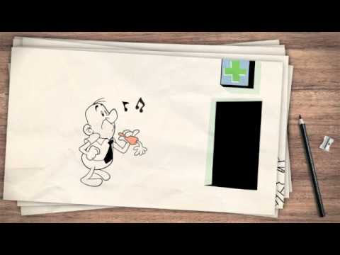
Lack of Empowerment
“People can experience disempowerment when they feel a “power over” them. .. Some health providers exhibit a paternalistic attitude toward people, characterized by the attitude of “I know what’s best for you or I can do it better.” This attitude can occur when the health care provider tells the person what to do, rather than developing a person-centred care (PCC) relationship in exploring self-management health strategies through shared decision making, …This disempowerment can lead to unsuccessful self-management activities and health outcomes. Empowerment should also extend to families. Lack of information about how to provide and support care, manage prescriptions, or recognize approaching crises can be major barriers to those who care for family members with health needs. Failure to assist people and their families in assuming self-management responsibility, or failure to provide appropriate resources and support, can inhibit empowerment” (Arnold and Boggs, pg. 229).

Trust

“Establishing trust is the foundation of all relationships. The development of a sense of interpersonal trust, a sense of feeling safe, is the keystone in the nurse–person relationship. Trust provides a non-threatening, interpersonal environment in which people feel comfortable revealing their needs. The nurse is perceived as dependable, competent, and not causing harm. The establishment of this trust is critical to enabling you to make an accurate assessment of health needs. Trust is also the key to establishing effective healthcare team relationships. Lack of trust in the workplace has detrimental effects on the organization and coworkers, undermining performance, and commitment” (Arnold and Boggs, pg. 229).

Reference:

“Trust is also the key to establishing effective health care team relationships. Lack of trust in the workplace has detrimental effects for the organization and for coworkers, undermining performance and commitment…In the nurse–person relationship, maintaining an open exchange of information contributes to trust. For the person receiving care, trust implies a willingness to place oneself in a position of vulnerability, relying on health care providers to perform as expected. Truthfulness and honesty is a basic building block in establishing trust. Studies show that people and their families or substitute decision makers want “complete honesty,” and most prefer complete disclosure” (Arnold and Boggs, pg. 229).
Techniques Designed to Promote Trust Box 12.1 (Arnold and Boggs, pg. 230).
• Convey respect.
• Consider the person’s uniqueness.
• Show warmth and caring.
• Use the person’s proper name.
• Use active listening.
• Give sufficient time to answer questions.
• Maintain confidentiality.
• Show congruence between verbal and nonverbal behaviours.
• Use a warm, friendly voice.
• Use appropriate eye contact.
• Smile.
• Be flexible.
• Provide for allowed preferences.
• Be honest and open.
• Give complete information.
• Provide consistency.
• Plan schedules.
• Follow through on commitments.
• Set limits.
• Control distractions.
• Use an attending posture: arms, legs, and body relaxed; leaning slightly forward.

Mistrust
“Mistrust has an effect not only on communication but on healing-process outcomes. Trust can be replaced with mistrust, as might occur if the nurse violates a person’s confidentiality. …An example might be a community health nurse who is inconsistent about keeping appointments or a pediatric nurse who indicates falsely that an injection will not hurt. Such behaviours create mistrust. It is hard to maintain trust in any situation when one person cannot depend on another. Having confidence in the nurse’s knowledge, skills, commitment, and caring allows the person to feel confident in the person–nurse relationship, in focusing on the health situation requiring resolution” (Arnold and Boggs, pg. 230).

Empathy
“Empathy is the ability to experience what another person or family member is feeling and then communicate understanding. Empathy is the ability to put yourself into another’s position. Being empathetic includes an individual’s ability to understand and feel the person’s experience, perspective, and feelings while remaining nonjudgmental; interpreting nonverbal communication; and meeting the person’s needs through a therapeutic relationship (Dean et al., 2017; Kiosses, et al., 2016). Empathy and empathetic communication are crucial to developing a therapeutic relationship and nursing practice. The ability to effectively communicate empathy is associated with meeting the person’s basic need to be understood and can lead to improved satisfaction and health outcomes (Arnold and Boggs, pg. 231).

“Communication skills for empathy: (Arnold and Boggs, pg. 231).
- active listening are used to convey respect and empathy…
- communicate your understanding of the meaning of a person’s feelings by using both verbal and nonverbal communication behaviours:
- maintain direct eye contact, ,
- use attending open body language,
- and keep a calm tone of voice.
- Acknowledging the person’s message about their feelings, difficulties, or pain helps create a positive connection (Williams et al., 2016). \
- Remember to validate accuracy by restating what you understand the person is conveying, and have them confirm verbally that this is accurate.
- If you need more information about their feelings, ask them to expand on their message, perhaps asking, “Are there other things about your experience that are bothering you?” or “Is there anything else you think I should know?”
- Once you have all the information needed, you can identify, with the person, interventions to address their health needs.
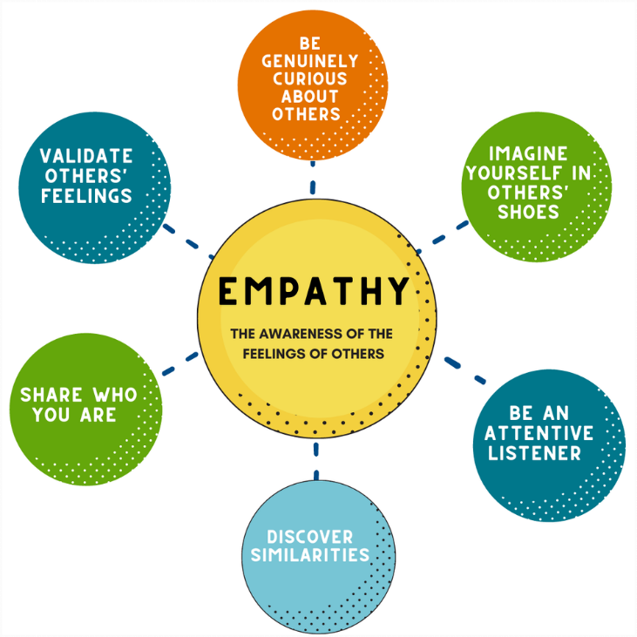
Reference:
Lack of Empathy
“A failure to understand a person’s needs may lead you to not provide required emotional support and educational support and meet the person’s health needs. Major organizational barriers to empathy exist in the clinical environment, including a lack of time associated with heavy workloads. Several studies suggest that a lack of empathy affects the quality of care, results in less favourable health outcomes, and lowers satisfaction by the person and family. As providers, we can consciously choose to express empathy” (Arnold and Boggs, pg. 231).

Evaluation:
See timeline or future tests and assignments.
References:

Boggs, C.M.O.Y.E.A. K. (2022). Arnold and Boggs's Interpersonal Relationships. Elsevier Health Sciences. Chapter 6 (US). https://pageburstls.elsevier.com/books/9780323763684
Roach, 1992 Roach SM. The Human Act of Caring Canadian Hospital Association Press 1992
Canadian Council for Practical Nurse Regulators, 2013. Standards of practice for licensed practical nurses in Canada. https://www.clpna.com/wp-content/uploads/2013/02/doc_CCPNR_CLPNA_Standards_of_Practice.pdf.
Berezin and Lamont, 2016 Berezin M, Lamont M. Mutuality, mobilization, and messaging for health promotion: Toward collective cultural change. Social Science &amp; Medicine. 2016;165:201–205
Chinn and Falk-Rafael, 2015 Chinn PL, Falk-Rafael A. Peace and power: A theory of emancipatory group process. Journal of Nursing Scholarship. 2015;47(1):62–69
Dean et al., 2017 Dean S, Williams C, Balnaves M. Living dolls and nurses without empathy. Journal of Advanced Nursing. 2017;73(43):757–759.
Williams et al., 2016 Williams B, Brown T, McKenna L, et al. Attachment and empathy in Australian undergraduate paramedic, nursing, and occupational therapy students: A cross-sectional study. Collegian. 2016;24(6):603–609 https://doi.org/10.1016/j.colegn.2016.11.004.
Swanson, K.M. (1991). Empirical development of a mid-range theory of caring, Nursing Research, 40(3), 161-166.

